Computer Vision
https://www.youtube.com/watch?v=yqkISICHH-U

https://github.com/nicknochnack/TFODCourse

https://www.youtube.com/watch?v=wEoyxE0GP2M&list=PLf7L7Kg8_FNxHATtLwDceyh72QQL9pvpQ&index=6

- CNN and fast R-CNN
Model for computer vision, for detecting multiple objects in an image.

http://www.huppelen.nl/publications/selectiveSearchDraft.pdf

https://arxiv.org/pdf/1311.2524.pdf

RPN (region proposal network)
In this method we take an image, apply cnn to create a feature map and then we create anchor boxes (rectangles) with different scales and ascept ratios for each point of a feature map. Those anchor boxes are part of an image, not a feature map.

RPN (region proposal network) takes those anchor boxes and outputs a set of good proposals which might contain an object which we want to detect.

For each anchor RPN outputs 2 different things.
The frist one is probability that anchor contains an object which we want to detect but it doesnt predict what class it is. The second output are 4 numbers: x_center, y_center, width, height which indicates how much we need to change a position and size of an anchor box in order to fit better to an object.

RoI Pooling (region of interest pooling)
https://erdem.pl/2020/02/understanding-region-of-interest-ro-i-pooling
We take an image and create a feature map using cnn.

Then we create different RoIs (regions of interest) using for example RPN (region proposal network). Those RoIs are part of an image, not feature map. Then we map those RoIs onto a feature map.
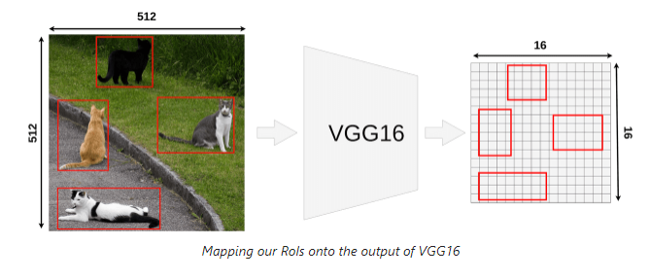
Let’s take a RoI which has (296, 192) coordinates of a top left corner, height = 145, width = 200. Feature map is 32 times smaller then the image so coordinates of a top left corner of the RoI, its width and height are also 32 times smaller.
- width: 200/32 = 6.25
- height: 145/32 = ~4.53
- x: 296/32 = 9.25
- y: 192/32 = 6
When we put a RoI on a feature map it looks like this
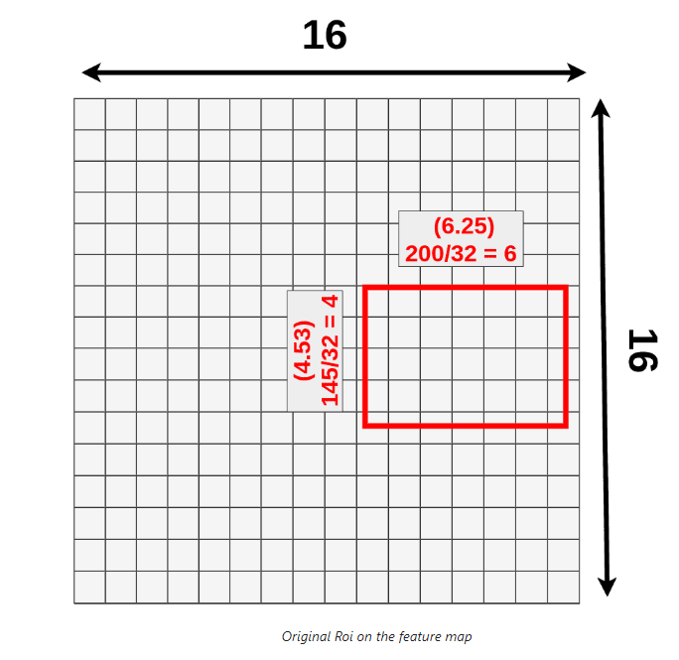
We cannot apply pooling because some of the cells are divided so we need to round parameters of the RoI
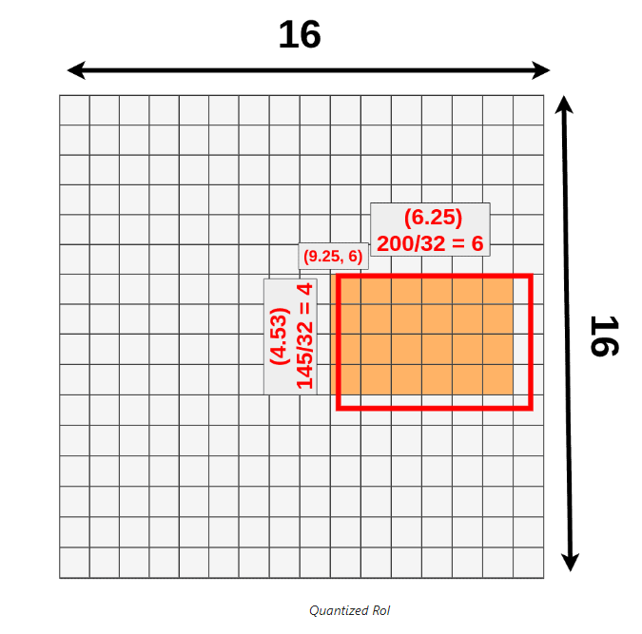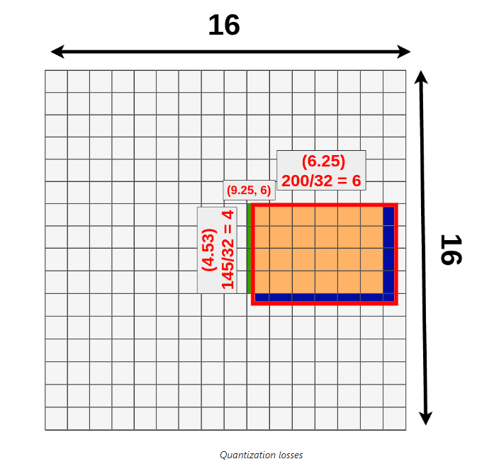

Blue section is the section which we lost and the green one is the one which we have added.
Now we want to apply max pooling such that we obtain 3x3 RoI pooling matrix. We cant divide 4 by 3 so again we need to round that number so we will take only a part of our RoI and apply max pooling to that
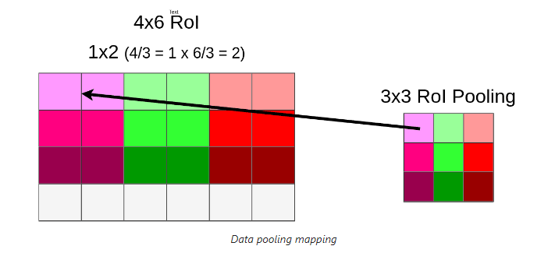

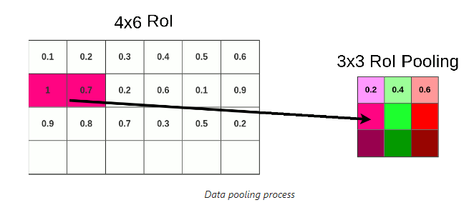

RoI Allign (modification of RoI Pooling)
https://erdem.pl/2020/02/understanding-region-of-interest-part-2-ro-i-align
We create a feature map and create on it a section corresponding to a RoI in the image.
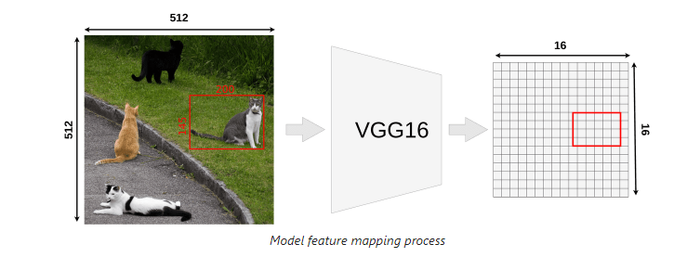

This is our RoI in the feature map
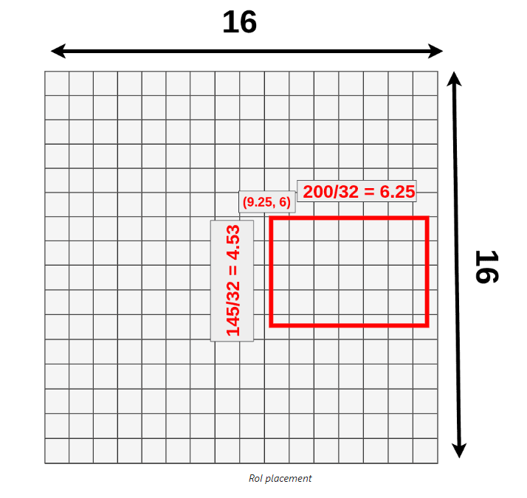

Now we divide our RoI into 9 boxes
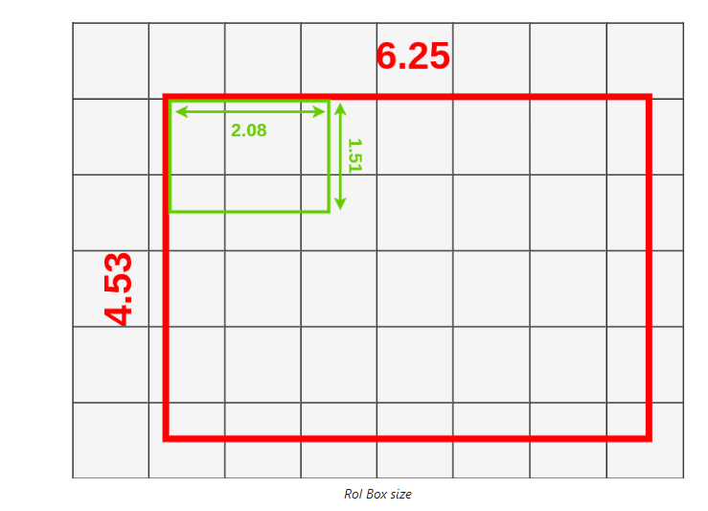

We sample 4 points inside each box
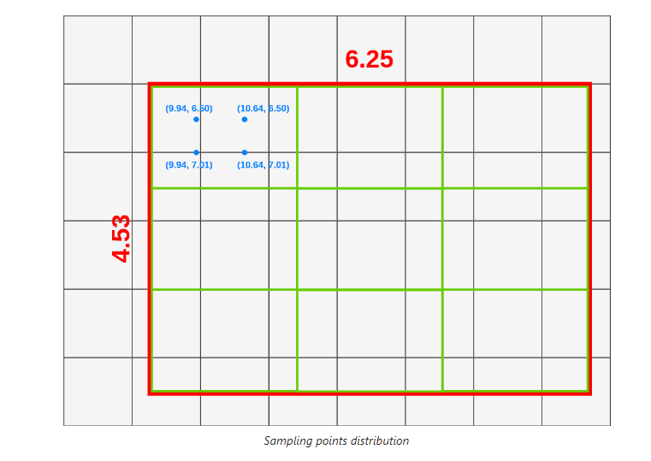

To calculate coordinates of those points we use this formula:
Top left point:
- X = X_box + (width/3) * 1 = 9.94
- Y = Y_box + (height/3) * 1 = 6.50
Bottom left point:
- X = X_box + (width/3) * 1 = 9.94
- Y = Y_box + (height/3) * 2 = 7.01
And the rest of points we calculate analogically.
Now we will use bilinear interpolation to calculate values for each point.
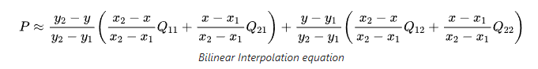
Here is the example of how those calculations looks like:
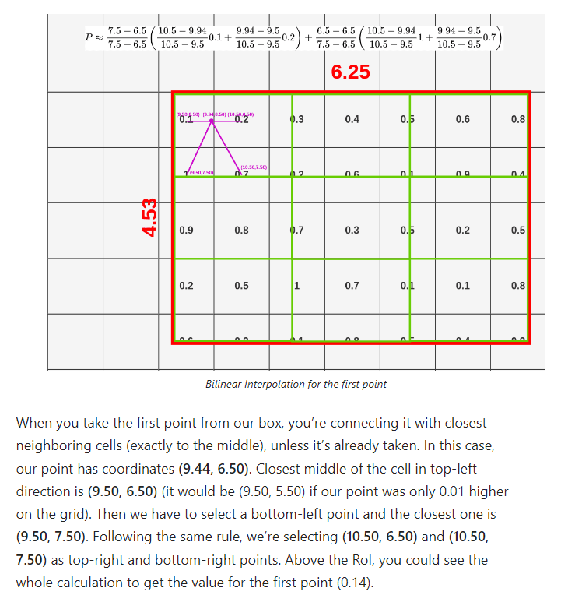
Now for each box we have created 4 points with assigned values. If we are using max pooling then for each box we are choosing max value and this gives us a RoI Align
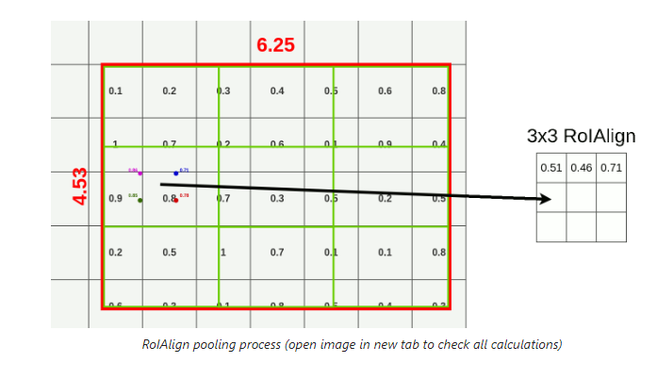

Mask R-CNN
Method for instance segmentation (detecting objects with classification of every pixel)

https://www.youtube.com/watch?v=4tkgOzQ9yyo

https://github.com/facebookresearch/Detectron

https://arxiv.org/pdf/1703.06870.pdf

Instance segmentation
https://openreview.net/pdf?id=C3ukgkqJuh0

Multiple object detection with anchor boxes
https://d2l.ai/chapter_computer-vision/anchor.html

